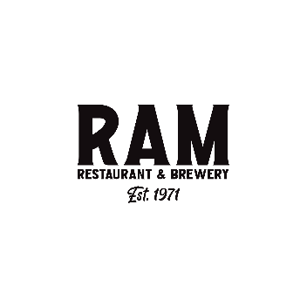
Non-Negotiable Steps of Service and Hospitality

- Guests will be greeted at the front door with a smile.
- Guests escorted to their table seated and then presented with menus.
- The host will point out daily specials and the beverage menu on the table.
- Servers will greet their guests in under two minutes.
- Servers will lead with daily specials, seasonal beer information and their favorite appetizer.
- All guests will be merchandised an appetizer to start with, sharable for larger groups, smaller sized for under four guests.
- All guests will be made aware of upgrades to their choices such as cheese or onions on a French Dip, sweet potato fries for a side, sub a wagyu burger.
- All tables will be merchandised a dessert. Mud pie is a can’t miss.
- All guests will be thanked for dining with us and asked to return soon.

