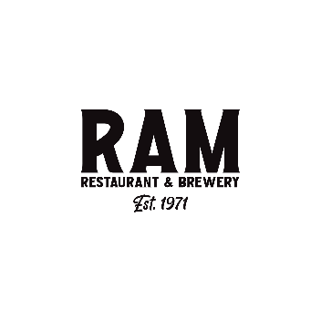
Service Team Member
The goal of the service team member is to make every table you have smile, laugh, remember your name and leave wanting to tell their friends about the amazing and memorable experience they received from you (calling you by name) at the Ram. Doing this builds your personal business as a server or bartender and drives more guests and sales to the Ram.
These are the non-negotiables of your position.
- Guests are greeted in less than 2 minutes
- We NEVER greet a table with “Can I get you something to drink”
- Give a welcoming greet to your table and then ask questions to find out what the guest wants or needs
  - “Have you been here before?”
    - If they say yes, ask them what their favorites are or what they had last time to have them want to come back to see us again. Listen to their answers and make suggestions from what they say. It easier to sell to a guest when you know what they are looking for – at the same time, make sure that they are aware of similar items they may enjoy based on the information they gave you.
        - We always want to be talking about our beer and include that in the initial contact with the guest, but it doesn’t always have to be the first thing out of your mouth
    - If they say no, tell them you are glad that they are here and let them know about our beer program and some of your favorites, to include the daily specials. Find out how they heard about us and what made them want to try us out. What they tell you may help you cater your service to what they are looking for
        - Tell a leader that you have a guest(s) that have never been here before. The leader can stop by and welcome them and thank them for coming in.
- Before leaving the table on the initial contact, the guest must know what our daily special is, where our seasonal beer selection is and suggest a favorite appetizer that the guest can consider ordering while you are getting their drinks
- Fall in love with two of everything on the menu and be able to sell/merchandise them with passion and conviction. 2 beers, 2 cocktails, 2 wine, 2 burgers, 2 salads, 2 sandwiches, 2 mains, etc.
- All `guests will be made aware of add ons to their choices. Avoid yes and no questions. If you ask “do you want to add bacon to that?” the guest can easily say no. Instead, if you say “bacon is a guest favorite addition to that and I highly recommend it”…………then wait for them to say yes
  - Suggestions from you can be server secrets. These are things that you have either tried or had a guest eat and they loved it. Let your guest know these secrets. It’s a way of selling without them feeling like they have been upsold. Example: If a guest orders a Turkey Havarti – “A guest favorite is to add avocado. I have tried it as well and it tastes amazing”
  - Every burger ordered should be merchandised with a Wagyu patty. Once again, avoid a yes or no question. “Every guest that I have had order a Wagyu patty with any one of our burgers tell me it’s the best burger they have ever had”. Say something like this instead of “do you want to have that with a Wagyu patty?”
- All guests will be merchandised a dessert.
  - Avoid yes or no questions. If you say “can I get you a Bread Pudding for dessert” it’s too easy for them to say no. Instead ask, “If you haven’t tried our bread pudding it is melt in your mouth good. It also makes the best French toast you have ever had if you want to get it to go instead and have it for breakfast.”
- All these things are to be done with a positive and uplifting attitude and a genuine and sincere delivery.
- The goal is to make a genuine connection with every guest at every table. You have made them smile, laugh and they now know your name. They have had a great experience and want to come back. You have done a great job. Now remember the most important thing – thank them for coming in AND tell them it was a pleasure meeting them and invite them back to see YOU. Build your business and make new “regulars” every day. Your personal and financial rewards will grow exponentially.

I understand the non-negotiables of my position and have been taught and shown how to do these things by a leader or certified trainer. I agree that I will do these things 100% of the time to ensure that every guest has a positive and memorable experience.
Game On!

__________________________________________________ ________________________
Name (Print & Sign) Date

